**Chapter 7-8 Interpersonal**

**Types of relationships**

* Acquaintances
  + People we know by name and talk with when the opportunity arises, but with whom our interactions are largely impersonal
* Impersonal communication
  + Interchangeable polite conversation that involves little personal disclosure
* Friends
  + People with whom we have negotiated more personal relationships that are voluntary
* Intimates
  + People with whom we share a high degree of commitment, trust, interdependence, disclosure and enjoyment
* Platonic relationships
  + Intimate relationship in which partners are not sexually attracted to each other or do not act on an attraction they feel
* Romantic relationships
  + Intimate relationship in which partners act on their sexual attraction
* Trust
  + Placing confidence in another in a way that almost always involves some risk
* Intimacy guidelines
  + Be dependable
  + Responsiveness in meeting partner’s needs
  + Collaborative in managing conflict
  + Faithful
  + Put relationship first
  + Transparency through honesty

**Disclosure and feedback**

* Self-disclosure
  + Sharing biographical information, personal ideas and feelings that are unknown to the other person
* Feedback
  + Verbal and physical responses to people within the relationship
* Johari window
  + Tool for examining the relationship between disclosure and feedback in the relationship

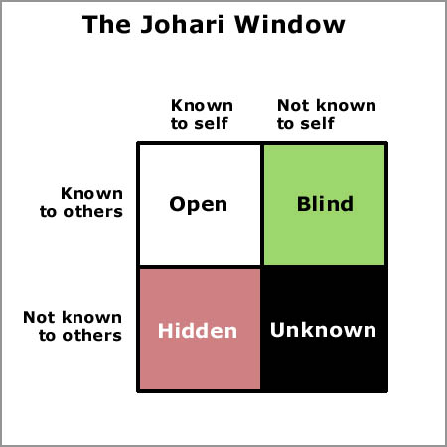

* Open pane
  + Information that both you and your partner know
* Secret pane
  + Things that you know about yourself but that your partner does not yet know about you
* Blind pane
  + The place for information that the other person knows about you, but about which you are unaware that they know
* Unknown/secret pane
  + Information that neither you nor your partner know about you
  + New experiences
* Size of each pane is negotiated through experience and feedback
* balance of appropriate disclosure and feedback for both partners is a sign of a healthy relationship
* Hiding information is problematic in a relationship

**Communication in the stages of relationships**

* Beginning relationships
  + Communication focuses on reducing uncertainty by increasing your knowledge of the other person
  + Goal is to understand how he or she sees the world
* Developing relationships
  + As relationship develops, you disclose more to one another
  + Engage in more physical contact
  + Feel more psychologically close to the other person
* Maintaining relationships
  + Both people participate in ways that keep the relationship at a particular level of closeness
  + Spending time together
  + Face-to-face vs. online intimacy
* Deteriorating and dissolving relationships
  + Relationship becomes less satisfying to one or both partners
  + Drifting apart occurs
  + Less communication during this phase
  + Relationships end when people no longer interact with one another
  + Ending a relationship?

**Dialectics in interpersonal relationships**

* Dialectic
  + Tension between conflicting personal images one shows others
* Relational dialectics
  + Competing psychological tensions in a relationship
* Autonomy-connection
  + Autonomy is the desire to do things independent of one’s partner
  + Connection is the desire to do things and make decisions with one’s partner
* Openness-closedness
  + Openness is the desire to share intimate ideas and feelings with one’s partner
  + Closedness is the desire to maintain one’s privacy in a relationship
* Novelty-predictability
  + Novelty is the uniqueness in the partner’s relationship
  + Predictability is the consistency, reliability and dependability in a relationship
* Managing dialectical tensions
* Temporal selection
  + Strategy of choosing one dialectical tension and ignoring its opposite
  + Spending more time together because of lack of connection
* Topical segmentation
  + Strategy of choosing certain topics to satisfy one dialectical tension
* Neutralization
  + Strategy of compromising between the desires of two partners
  + Spontaneity in a relationship
* Reframing
  + Strategy of changing one’s perspective about the level of tension
  + Discuss issues that bother one partner and determine whether those issues are as serious as perceived
  + One partner communicates more openly than the other

**Interpersonal communication skills**

**Comforting messages**

* Comforting
  + Helping people feel better about themselves, behavior or situation by providing a safe conversational space
* Buffering messages
  + Comforting messages that are phrased very positively in ways that address another person’s face needs
* Positive face needs
  + Desire to for appreciation or approval
* Disclosure in relationships
* Disclosure
  + Revealing confidential information about oneself or others
* Privacy
  + Right of an individual to keep information secret
* Privacy management
  + Exercising personal control over confidential information

**Types of behavior**

* Passive
  + Not expressing an opinion because we fear the cost of expressing such an opinion
* Aggressive
  + Belligerently confronting another with your preferences with little disregard for the feelings of others
* Assertive
  + Expressing your personal preferences while respecting the preferences of others

Styles of conflict

* Withdrawing
  + Managing conflict by removing yourself physically or emotionally
* Accommodating
  + Managing conflict by accepting what other want or need and ignoring your own wants or needs
* Forcing
  + Managing conflict by forcing your wants and needs on another person
* Compromising
  + Managing conflict by giving up part of what you want to satisfy the other